WORK INSTRUCTIONS FOR

Assigning SeRP user access permissions in Security 3

1. **PURPOSE**

To outline the steps for a data custodian to add a new end user to a project and assign access permissions.

Terms

“End user” – the person who is applying for access permissions to a project

“Administrator” – the person who is granting access permissions and carrying out the procedure defined in this work instruction.

Pre-requisites:

* End user has an Active Directory account that has been linked to Monash SeRP
* Administrator has access to the Security 3 portal and to the project where access permissions are to be applied. Request for access can be raised to the Monash SeRP Administrator. safehavens@monash.edu
* Administrator is logged into Monash VPN

1. **RESPONSIBILITIES**

Administrator is responsible for ensuring the end user should have access to the project.

1. **PROCEDURE**
2. Access URL: <https://serp-portal.erc.monash.edu/>, login using Monash ID and password
3. After successful login, the Security 3 console will appear

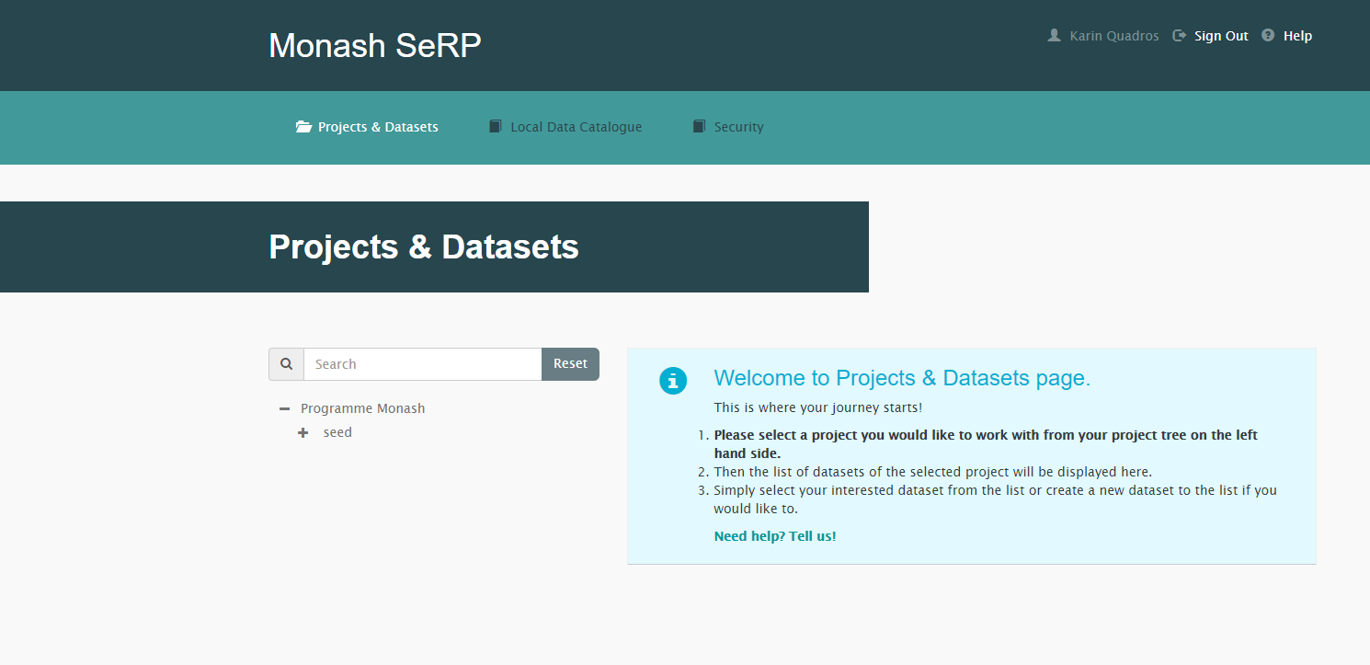

1. Select Security
2. Find the relevant project from the left-hand menu using the search function or browse by expanding the project tree (+/-).

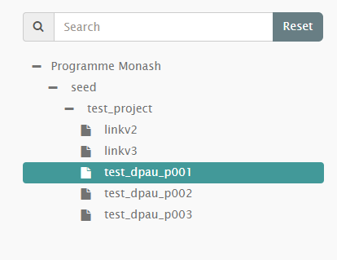

1. To add end users to the project, select the role you would like the user to have access to. Scroll to “Roles” section. A predefined set of user roles will display.

|  |  |
| --- | --- |
| **Role type** | **Access** |
| Analyst | Read only access  Can:   * Open and view files on the P: drive. * Copy files from P drive to U drive within the Analysis Environment   Cannot:   * Access Security 3 portal * Edit or delete files * Add files to the P: drive |
| ProjectManager | Read/Write access  Within the virtual environment:  Can:   * Open and view files on the P: drive. * Copy files from P drive to U drive within the within the Analysis Environment * Edit or delete files * Add files to the P: drive   Cannot:   * Access Security 3 portal |
| ProjectLead | Project portal access with ability to add/remove users  Can   * Open and view files on the P: drive * Copy files from P drive to the U drive within the Analysis Environment * Edit or delete files * Add files to the P: drive * Access Security 3 portal * Add/remove users via Security 3 portal * Change user access permissions via Security 3 portal   Cannot   * Add/edit projects * Approve File in/file out |
| DataApproval | Ability to approve file in/out for the project  Needs to be appended with ProjectLead or ProjectManager role.  Can:   * Approve/Reject requests to transfer files out* of analysis environment   *Note: the approval process to transfer files into the analysis environment is disabled. Users may transfer any file into the environment.  Cannot:   * Open and view files on the P: drive * Copy files from P drive to U drive within the Analysis Environment * Access Security 3 portal * Edit or delete files * Add files to the P: drive |

1. Select the role to view a list of the current members.

Membership consists of two types:

1. Member

A user that has been specifically added to the role.

1. Virtual Role Member

A user that has inherited the role as a result of being assigned to a parent project. This membership type is only available to the Monash SerP Technical Support Team.

1. To add an end user, click “Add User to Role”

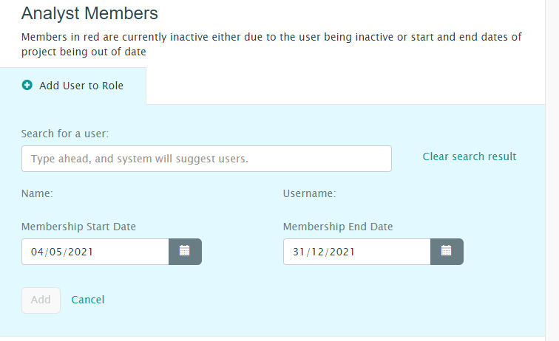

1. Search to add an end user to the role (note, the end user must have their active directory account linked to Monash SeRP for them to appear in the search function)
2. The default membership timeframe is set to the period of the project start and end date. This can be overwritten with a custom timeframe for the user. However, the membership end date cannot exceed the project end date.
3. Click add
4. Changes are reflected within 2 hours
5. **REFERENCES**
   1. **Internal**

* User Story 2.1 Work instruction for Creating Monash SeRP accounts

|  |  |  |  |
| --- | --- | --- | --- |
| DOCUMENT HISTORY | | | User Story 2.2 |
| Version no. | Date of Issue | Reviewed by: name | Amendments |
| 1 | 04/05/2021 |  | Created |
| 2 |  |  |  |
|  |  |  |  |
|  |  |  |  |
|  |  |  |  |